Test Case: tc002_SPX_Dev5_Crear_Requisicion_Spot_Con_FAD_Tipo_Cobro_CC
Step 1 - Enter username and password and click to button Enter : Credentials Entered
Image file-name: QC_Testing-tc002_SPX_Dev5_Crear_Requisicion_Spot_Con_FAD_Tipo_Cobro_CC-1789485545064

Step 2 - Select to UEN and Access to Spot Buy Requisitions : UEN Correctly selected and Correct access
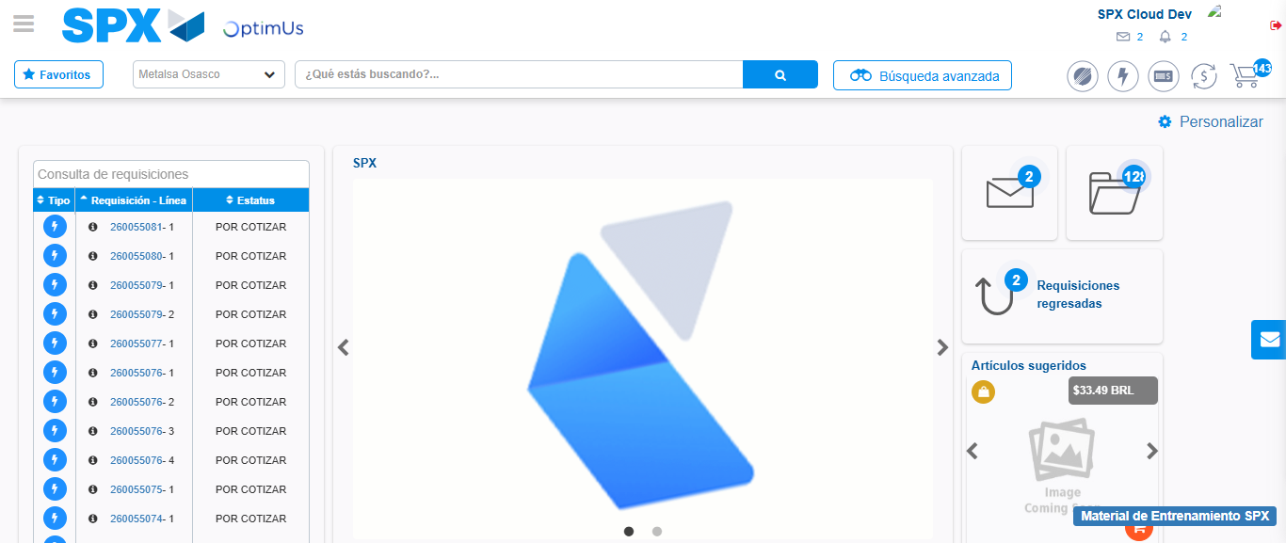Image file-name: QC_Testing-tc002_SPX_Dev5_Crear_Requisicion_Spot_Con_FAD_Tipo_Cobro_CC-1789485575495

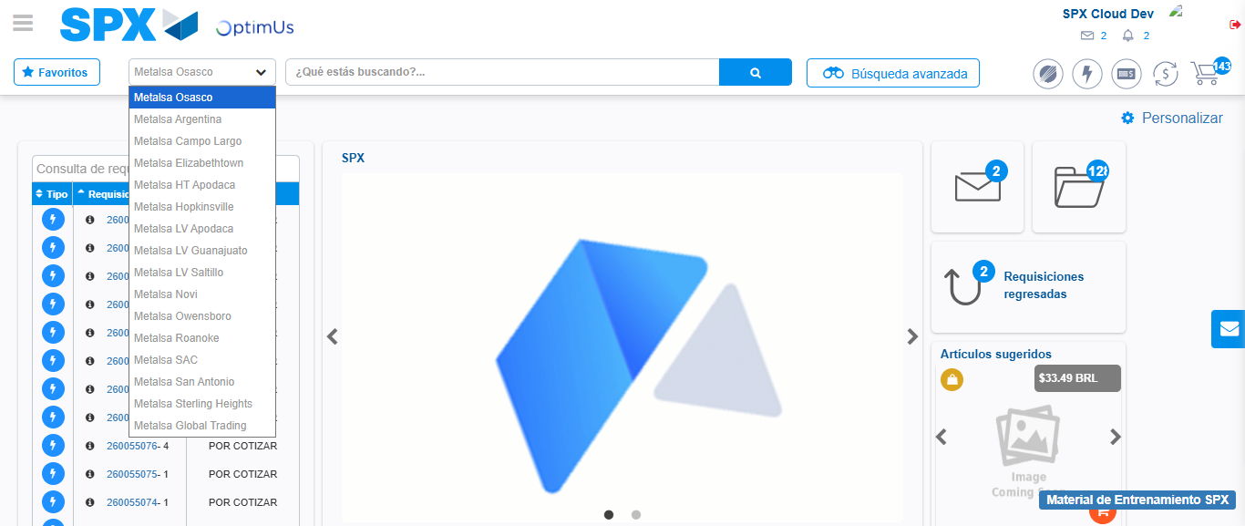Image file-name: QC_Testing-tc002_SPX_Dev5_Crear_Requisicion_Spot_Con_FAD_Tipo_Cobro_CC-1789485575947

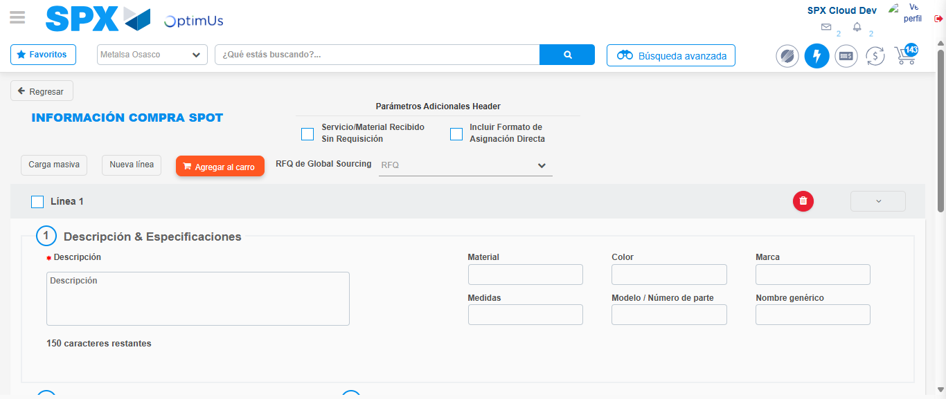Image file-name: QC_Testing-tc002_SPX_Dev5_Crear_Requisicion_Spot_Con_FAD_Tipo_Cobro_CC-1789485580072

Step 3 - Add FAD to Requisition: FAD Successfully Added
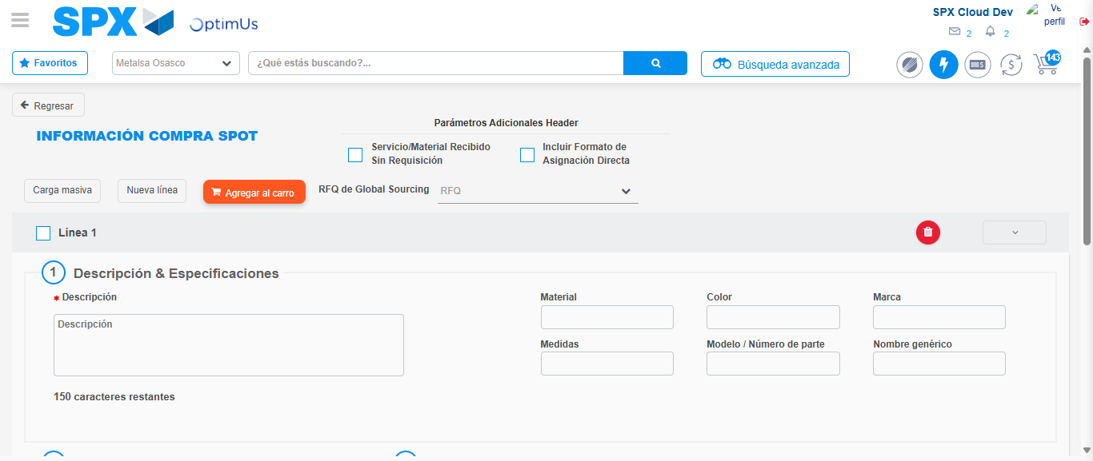Image file-name: QC_Testing-tc002_SPX_Dev5_Crear_Requisicion_Spot_Con_FAD_Tipo_Cobro_CC-1789485580286

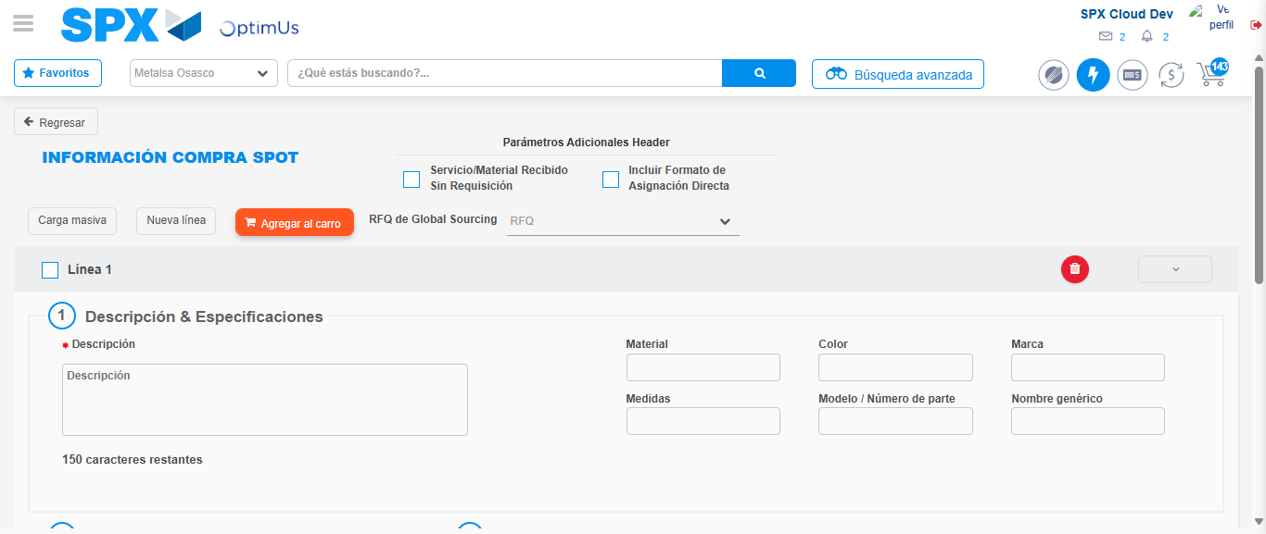Image file-name: QC_Testing-tc002_SPX_Dev5_Crear_Requisicion_Spot_Con_FAD_Tipo_Cobro_CC-1789485580481

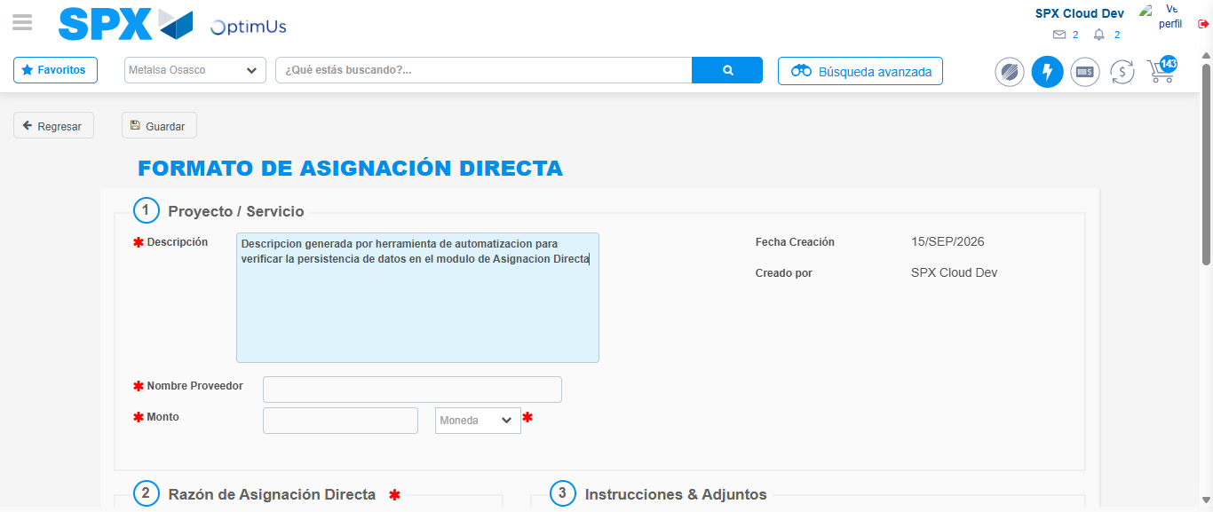Image file-name: QC_Testing-tc002_SPX_Dev5_Crear_Requisicion_Spot_Con_FAD_Tipo_Cobro_CC-1789485583262

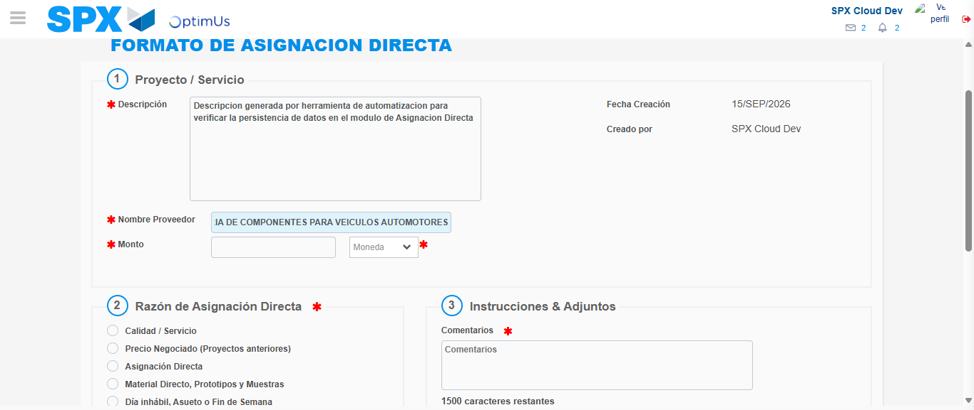Image file-name: QC_Testing-tc002_SPX_Dev5_Crear_Requisicion_Spot_Con_FAD_Tipo_Cobro_CC-1789485591765

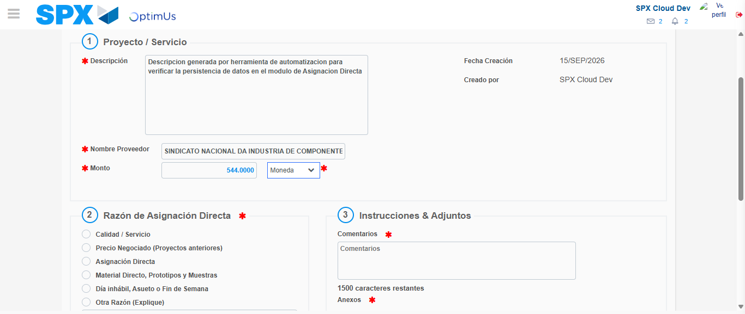Image file-name: QC_Testing-tc002_SPX_Dev5_Crear_Requisicion_Spot_Con_FAD_Tipo_Cobro_CC-1789485592161

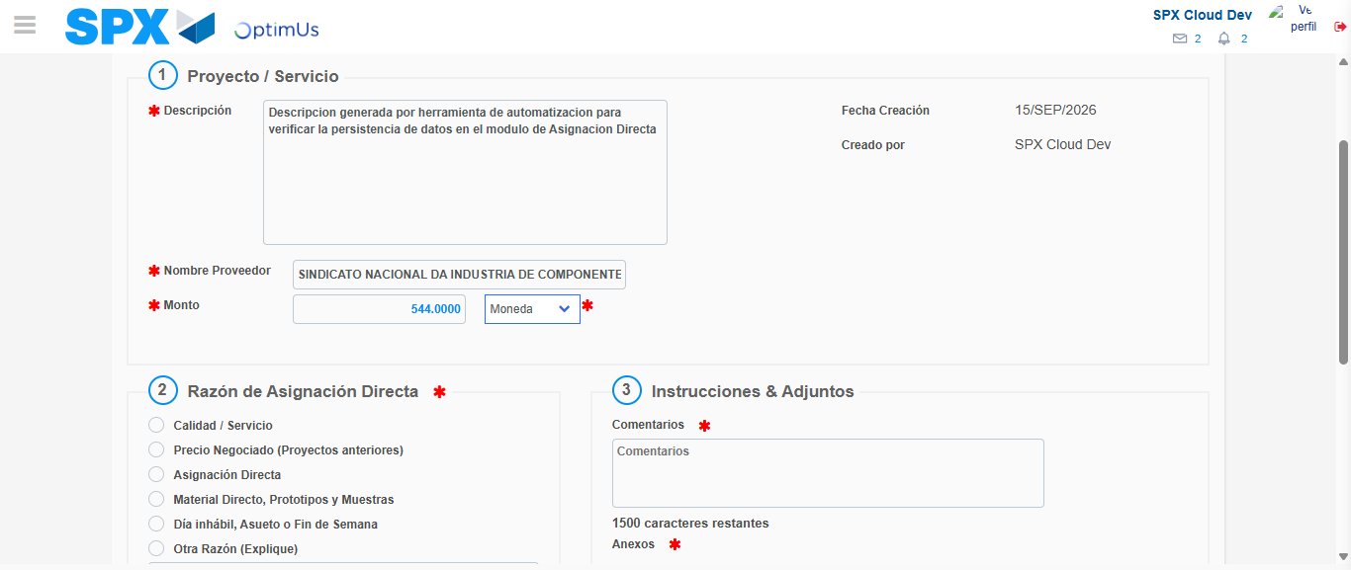Image file-name: QC_Testing-tc002_SPX_Dev5_Crear_Requisicion_Spot_Con_FAD_Tipo_Cobro_CC-1789485592359

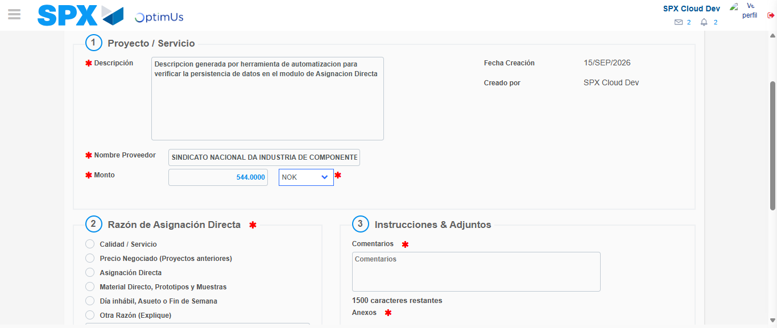Image file-name: QC_Testing-tc002_SPX_Dev5_Crear_Requisicion_Spot_Con_FAD_Tipo_Cobro_CC-1789485592655

Image file-name: QC_Testing-tc002_SPX_Dev5_Crear_Requisicion_Spot_Con_FAD_Tipo_Cobro_CC-1789485592825

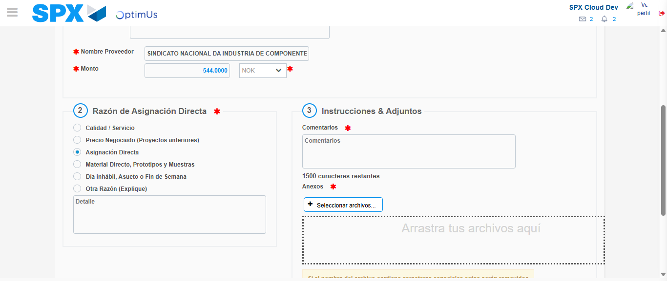Image file-name: QC_Testing-tc002_SPX_Dev5_Crear_Requisicion_Spot_Con_FAD_Tipo_Cobro_CC-1789485593589

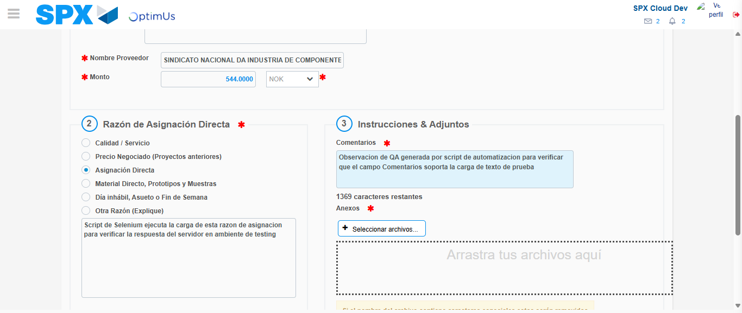Image file-name: QC_Testing-tc002_SPX_Dev5_Crear_Requisicion_Spot_Con_FAD_Tipo_Cobro_CC-1789485604513

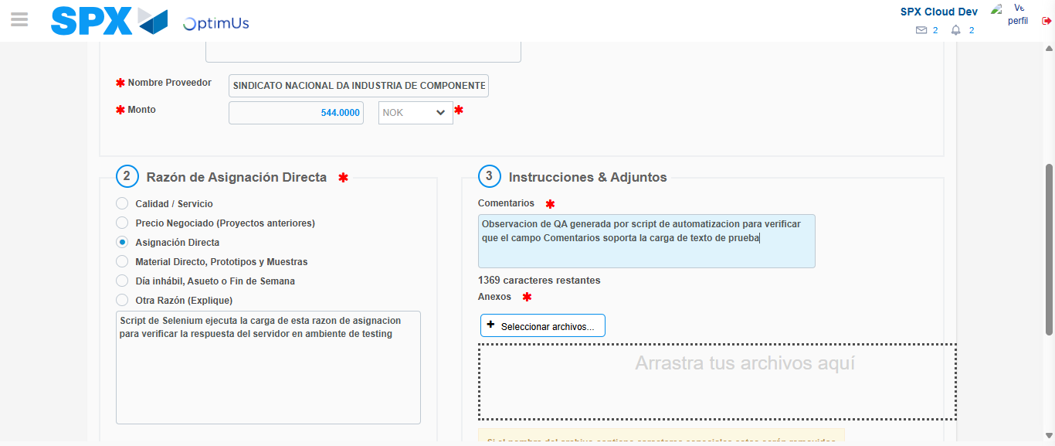Image file-name: QC_Testing-tc002_SPX_Dev5_Crear_Requisicion_Spot_Con_FAD_Tipo_Cobro_CC-1789485605006

Step 4 - Data Capture Spot Buy Requisition: Data captured correctly
Image file-name: QC_Testing-tc002_SPX_Dev5_Crear_Requisicion_Spot_Con_FAD_Tipo_Cobro_CC-1789485580286

Image file-name: QC_Testing-tc002_SPX_Dev5_Crear_Requisicion_Spot_Con_FAD_Tipo_Cobro_CC-1789485580481

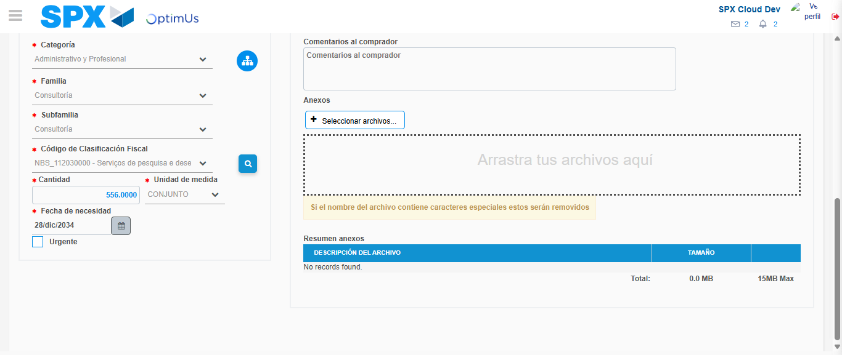Image file-name: QC_Testing-tc002_SPX_Dev5_Crear_Requisicion_Spot_Con_FAD_Tipo_Cobro_CC-1789485620986

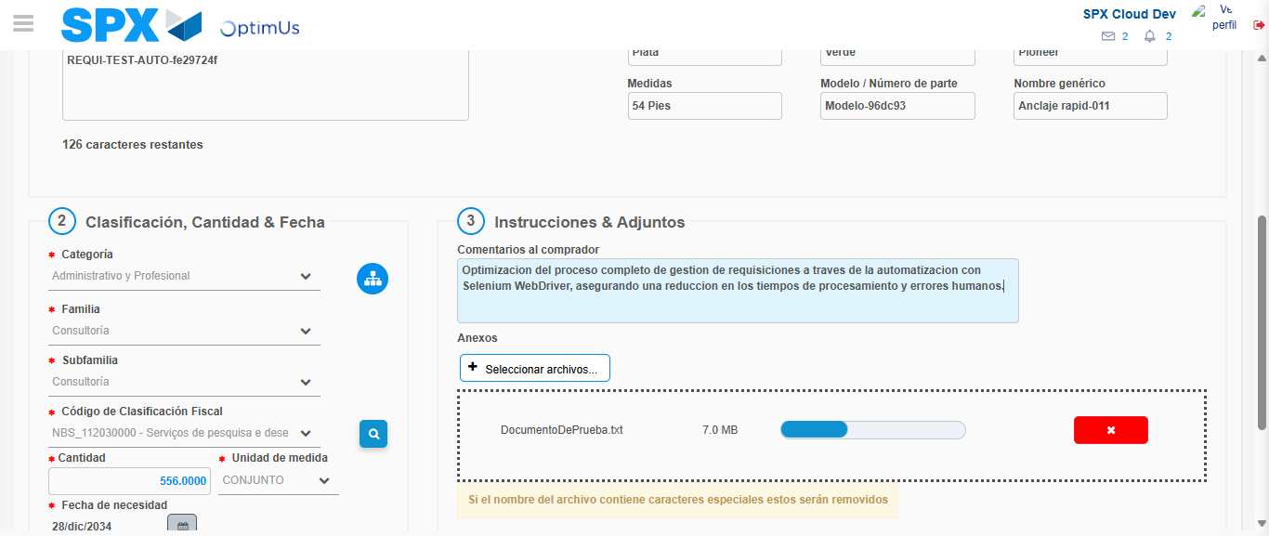Image file-name: QC_Testing-tc002_SPX_Dev5_Crear_Requisicion_Spot_Con_FAD_Tipo_Cobro_CC-1789485621699

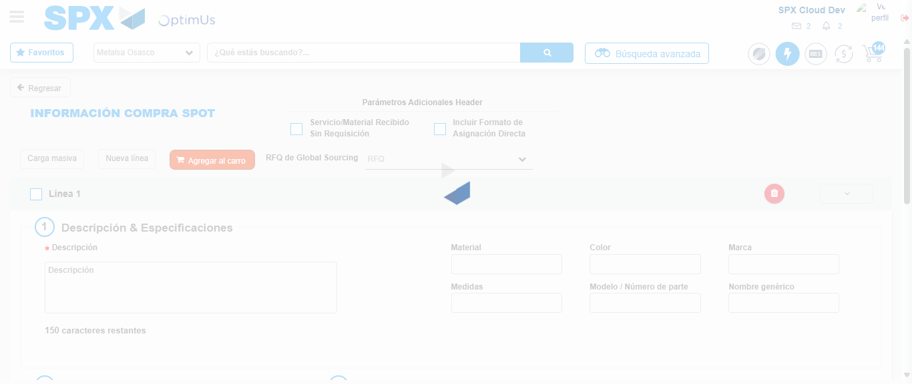Image file-name: QC_Testing-tc002_SPX_Dev5_Crear_Requisicion_Spot_Con_FAD_Tipo_Cobro_CC-1789485635884

Step 8 - Return to Main Page SPX : Return to Main Page SPX
Image file-name: QC_Testing-tc002_SPX_Dev5_Crear_Requisicion_Spot_Con_FAD_Tipo_Cobro_CC-1789485575495

Image file-name: QC_Testing-tc002_SPX_Dev5_Crear_Requisicion_Spot_Con_FAD_Tipo_Cobro_CC-1789485575947

Image file-name: QC_Testing-tc002_SPX_Dev5_Crear_Requisicion_Spot_Con_FAD_Tipo_Cobro_CC-1789485580072

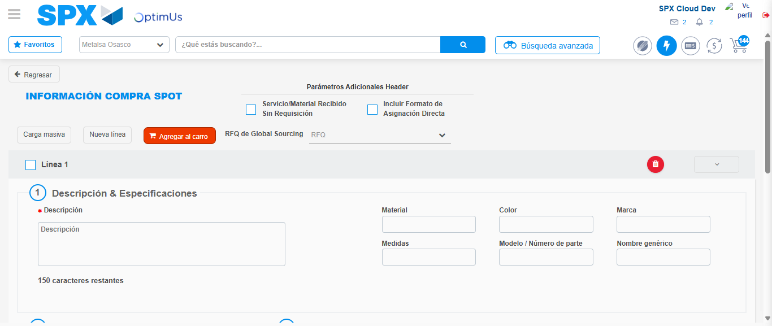Image file-name: QC_Testing-tc002_SPX_Dev5_Crear_Requisicion_Spot_Con_FAD_Tipo_Cobro_CC-1789485638086

Image file-name: QC_Testing-tc002_SPX_Dev5_Crear_Requisicion_Spot_Con_FAD_Tipo_Cobro_CC-1789485638249

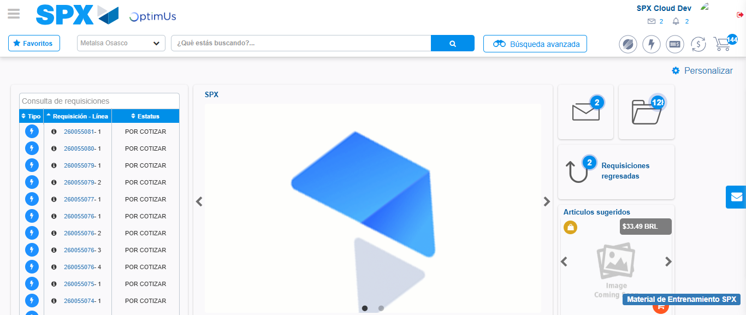Image file-name: QC_Testing-tc002_SPX_Dev5_Crear_Requisicion_Spot_Con_FAD_Tipo_Cobro_CC-1789485659519

Step 9 - Log Out : Log Out SPX
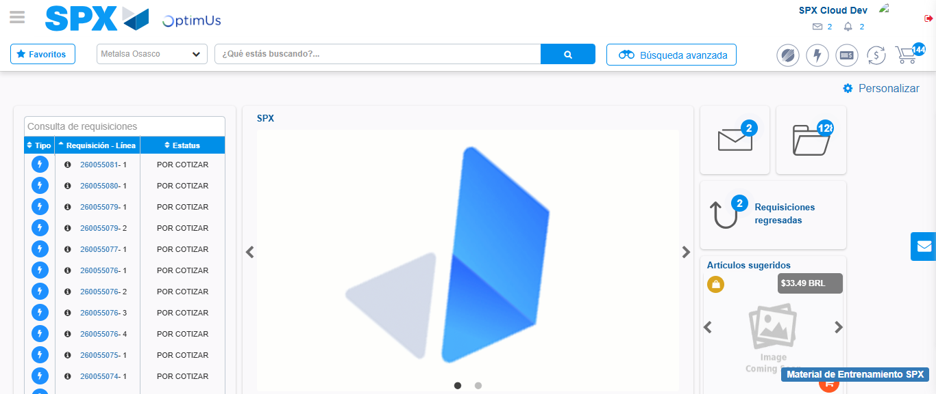Image file-name: QC_Testing-tc002_SPX_Dev5_Crear_Requisicion_Spot_Con_FAD_Tipo_Cobro_CC-1789485659874

